HR ANALYTICS REPORT: Employee Attrition Analysis
By:Analytics Team , People charm
- PROBLEM STATEMENT :
The organization is experiencing voluntary exits across multiple departments, and the underlying drivers of attrition are not clearly understood. Without data-driven insights, HR interventions may remain reactive rather than strategic.

This analysis aims to:
- Identify the overall attrition rate within the organization
- Determine key factors influencing employee exits
- Highlight high-risk employee segments
- Provide actionable, business-focused HR recommendations to reduce attrition

- BUSINESS IMPACT OF ATTRITION :
Employee attrition directly affects:
- Productivity and operational efficiency
- Recruitment, onboarding, and training costs.
- Team morale and employee engagement.
- Leadership pipeline and succession planning.
Even a moderate increase in attrition can significantly impact profitability and long-term growth.

- FACTORS INFLUENCING EMPLOYEE EXITS:
The following analysis explores the key patterns and risk segments contributing to employee attrition.

- Overall attrition rate:16.6%

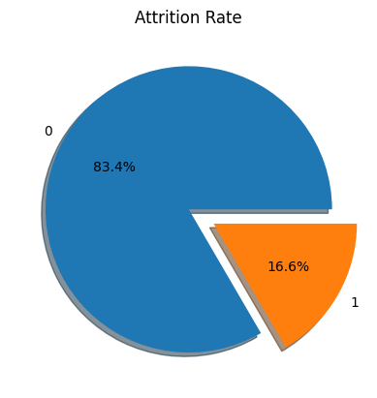
With an attrition rate of 16.6%, the organization faces a moderate but strategically important workforce retention challenge.

- Key Drivers of Employee Attrition:

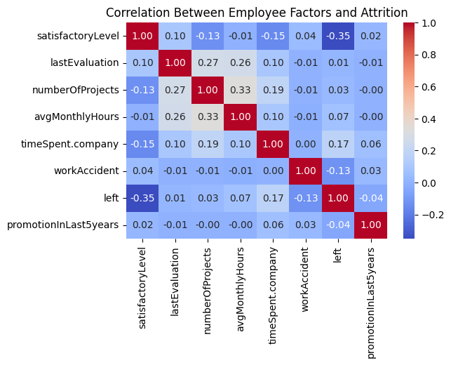
The heatmap identifies employee satisfaction(satisfaction level) as the strongest driver of attrition, with lower satisfaction significantly increasing exit risk.
Tenure(time spent at company) shows a moderate positive relationship with attrition, indicating potential career stagnation after certain years. Other factors such as workload and performance evaluation have minimal impact.
- Attrition Analysis by Department:
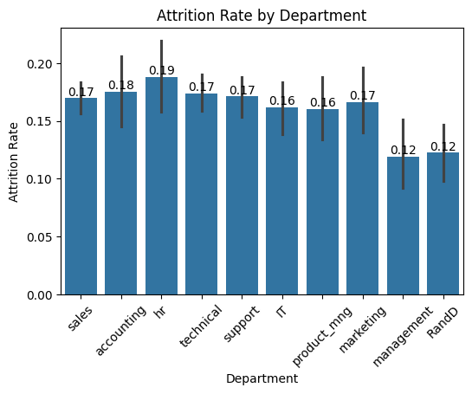
HR (19%) and Accounting (18%) exhibit marginally higher attrition compared to other departments (~17%), indicating slightly elevated exit risk within these functions.
- Attrition Analysis by Salary Level:
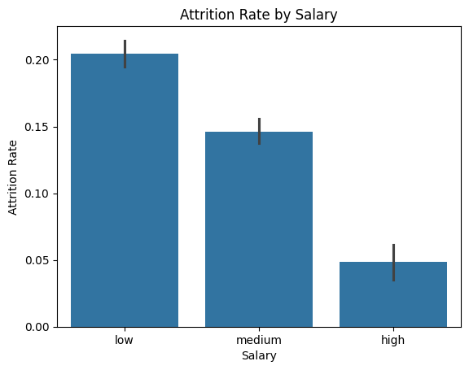
Attrition is significantly higher among employees in the low salary category, indicating that compensation is a key retention driver within the organization.
- SUMMARY:
- The organization’s attrition rate is 16.6%, indicating a moderate retention concern.

- Analysis shows that low employee satisfaction is the primary driver of attrition. Employees in the low salary band are significantly more likely to leave, highlighting compensation as a key factor. Attrition is slightly higher in HR and Accounting, though exits are generally distributed across departments.

- Improving engagement, reviewing compensation for lower salary bands, and strengthening career growth opportunities can help reduce attrition.

- RECOMMENDED HR ACTIONS:
Based on the analysis, the following actions are recommended to reduce attrition:

- Strengthen Employee Engagement: Implement regular engagement surveys and targeted interventions to improve satisfaction levels, particularly among at-risk groups.
- Review Compensation Strategy: Reassess salary structures for low-band employees and introduce performance-linked incentives or retention bonuses to reduce financial-driven exits.
- Career Growth & Internal Mobility: Develop structured career progression plans, especially for mid-tenure employees, to prevent stagnation-related attrition.
- Department-Specific Retention Focus: Conduct targeted discussions and workload assessments within HR and Accounting teams to address potential functional challenges.
A proactive, data-driven retention strategy focused on engagement, compensation alignment, and career development will significantly reduce future attrition risk.

